



|  |  |
| --- | --- |
|  |  |

Data Compliance Test (DCT)

Test Cases for

Immunisation Record

*<HCP Name>*

Table of Contents

1 Testing Instructions to HCPs 3

1.1 Self-Service Testing Phase 3

1.2 Final Testing Phase 3

1.3 Preparation DCT Test Report 4

2 Test Case Details 5

IMMU-LV3-001 [FOR LEVEL 3 DATA UPLOAD ONLY] 5

IMMU-LV3-002 [FOR LEVEL 3 DATA UPLOAD ONLY] 8

IMMU-LV2-001 [FOR LEVEL 2 DATA UPLOAD ONLY] 11

IMMU-LV2-002 [FOR LEVEL 2 DATA UPLOAD ONLY] 13

IMMU-LV1-001 [FOR LEVEL 1 DATA UPLOAD ONLY] 15

IMMU-LV1-002 [FOR LEVEL 1 DATA UPLOAD ONLY] 17

3 Appendix – Sample Messages 20

4 Appendix – Testing HCP and HCRs Information 23

5 Appendix – Sample Results in eHR Viewer (EVE) 24

6 Appendix – Actual Data Values (Sample) 28

# Testing Instructions to HCPs

## Self-Service Testing Phase

* After development of the data upload programmes, you can use the **Self-Service test accounts and test HCRs** provided by eHealth for connection to the eHealth testing environment and proceed with the self-service testing.
* You can proceed with the Self-service test at your own pace by following this Self-Service Testing Guide and using the test cases provided in section 2.
* You can verify the **correctness** and **completeness** of the data upload by:
* checking the interface files / messages generated in your system against the sample expected results of interface files /messages for all test cases as provided;
* checking the results on eHR Viewer (EVE) by logging into the testing eHealth with the provided test account; and
* checking the upload status through Process Summary and Exception Report in eHR Inbox by logging into the testing eHealth.
* For data fields requiring eHR Codex values, you can refer the Code Sets provided with the Self-Service Kit.
* For details of technical requirements of the data interface files, please refer to the ‘Quick Guide for Immunisation Data Upload.docx’.
* You are required to perform the test cases that are relevant to the data compliance level (Level 1, 2 or 3) supported by your clinic.
* You are required to perform the first batch of data upload by **Data Materialization** (**DM**) mode. **DM mode** is denoted in the interface by a fixed value **BL-M** in *HL7 OBX.4.*
* You should use **Incremental Load** (**INC**) mode for the second batch of data upload to update the previously uploaded records. **INC mode** is denoted in the interface by a fixed value **BL** in *HL7 OBX.4.*
* Since the **DM** mode would replace the corresponding records previously uploaded to eHealth, you may repeat your testing unlimited number of times by uploading the first batch by **DM** mode.
* It should be noted that the data field “Record Key” should be unique for each vaccine record (in level 2 & 3) or each PDF/Text report (in level 1).
* When all required test cases can be completed smoothly and correctly in this phase, you can proceed to the Final Testing Phase and submit **production environment setup form** to eHR DCT Support for preparation.

## Final Testing Phase

* You can start the Final Testing Phase once all test cases in the Self-Service Testing phase are passed.
* You should start Final Test by executing the test cases provided in section 2 with **Final Testing HCRs** provided by eHR DCT Support.
* You can verify the **correctness** and **completeness** of testing results by checking results in eHR Viewer (EVE) and the upload status through Process Summary and Exception Report in eHR Inbox.
* For Immunisation DCT test cases, there are **TWO** batches of data files / transactions to be uploaded to the testing eHealth. The required records must be correctly uploaded from these 2 consecutive batches respectively.
* The Final Test will be considered PASSED if all the following criteria are met:
* The **TWO** batches of test data files are uploaded consecutively in the correct sequence. The second batch of data files/transactions must be submitted after completion of processing of the first batch by eHealth.
* No additional data files / transactions are uploaded in between or after the uploads of the above two batches of data files / transactions to amend any records.
* No exception records are reported from the uploads.
* No manual interventions have been made to the data files / transactions.
* If the Final Test failed, you can re-attempt the Self-Service Test and Final Test until a successful run can be completed.

## Preparation DCT Test Report

* Once you have successfully passed the Final Test based on the above criteria, you should complete this document by attaching the below items to this document at the appropriate space provided:
  + Actual data files uploaded
  + Screen-shot of each test case
* You are required to submit this completed ‘DCT Test Cases’ document to eHR DCT Support for further processing. eHR DCT Support will provide feedback **within 10 working days**.

# Test Case Details

| **1** | **Test Case ID** | IMMU-LV3-001 [FOR LEVEL 3 DATA UPLOAD ONLY] | |
| --- | --- | --- | --- |
|  | **Function Description** | HCP has received the sharing consents from testing HCRs, then perform first data upload of HCRs’ clinical records to eHealth by DM Mode for Level 3 data. | |
| **Subsequent case of** | N/A | |
| **Testing Assumption** | * HCR1-HCR2 have already given sharing to sharing consents to the HCP. * The EMR system (EMRS) will upload Batch 1 data files to eHealth with all immunisation records of <HCR1> - <HCR2> created by DM mode. | |
| **Test Actions** | HCP creates below immunisation records in EMR system: | |
| 1a | **Case scenario:** Input new **Seasonal Influenza** vaccination record with *valid* vaccine description according to HCP elected recognised terminology for <HCR1> in the EMRS as follows:   * Vaccine administration date = 01-Feb-2024 10:00:00 * Vaccine local description = Seasonal Influenza 2023/2024 * Historical immunisation = N * Route of administration local description = Intramuscular * Site of administration local description = Left arm   == Actual data values (Refer to “Appendix - Actual Data Values (Sample)” for details)  Expected data contents for Level 3 interface record:   * Vaccine administration date = 01-Feb-2024 10:00:00 * Vaccine - recognised terminology name = HKCTT / RPP * Vaccine identifier - recognised terminology = 6102037 / 36956 * Vaccine description - recognised terminology = influenza seasonal vaccine / VAXIGRIP PURIFIED FLU VACCINE * Vaccine local description = [as provided by source system] * Historical immunisation = N * Vaccination provider code = Private * Vaccination provider description = Private hospital /clinic * Vaccination provider local description = [as provided by source system] * Route of administration code = IM * Route of administration description = Intramuscular * Route of administration local description = [as provided by source system] * Site of administration code = LA * Site of administration description = Left arm * Site of administration local description = [as provided by source system] |
| 1b | **Case scenario:** Input new **Pneumococcal** vaccination record with *invalid* vaccine description according to HCP elected recognised terminology for <HCR2> in the EMRS as follows:   * Vaccine administration date = 01-Feb-2024 10:00:00 * Vaccine local description = Pneumococcal (PCV13) * Historical immunisation = N   == Actual data values (Refer to “Appendix - Actual Data Values (Sample)” for details)  Expected data contents for Level 3 interface record:   * Vaccine administration date = 01-Feb-2024 10:00:00 * Vaccine - recognised terminology name = HKCTT / RPP * Vaccine identifier - recognised terminology = 6102823 / 59600 * Vaccine description - recognised terminology = **Pneumococcal (PCV13)** * Vaccine local description = [as provided by source system] * Historical immunisation = N * Vaccination provider code = Private * Vaccination provider description = Private hospital /clinic * Vaccination provider local description = [as provided by source system]   *Remark: Record will show in “Re-grade Report” as Vaccine description - recognised terminology not matched the Vaccine identifier - recognised terminology in IAMS.* |
|  | **Expected eMR System Behavior** | 1. HCP’s EMR system will upload **Batch 1** data for insertion of the following immunisation records by **DM mode**:  * **Level 3:** data from test cases **1a-1b**  1. **Batch 1** data files should include below files: <samples>    1. Participant List (PL)    2. Data File (DF)    3. HL7 message with signature    4. Zip File (embedded PL, DF and HL7 message files)    5. Zip Control File (contains the filenames of PL, DF and HL7 message) 2. EMR system uploads **Batch 1** data files (‘Zip File’ and ‘Zip Control File') to eHealth. 3. HCP verifies the data upload status by reviewing the 'Process Summary Report' and 'Exception Report' in eHR Inbox. 4. HCP verifies the completeness and correctness of data uploaded in eHR Viewer | |
|  | **Results Verification** | * HCP verifies the interface file contents and check if the uploaded records can be properly viewed in eHR Viewer (EVE). HCP must also review if the data batches uploaded can be processed successfully or rejected through ‘Process Summary’, ‘Exception Report’ and ‘Re-grade Report’ in eHR Inbox. | |
| **Actual Result**  **(Screenshot / Attachment)** | **Data Files Uploaded:**  *<Attached the Zip file and Control file; password to unzip the file>* | |
| **Attachment/Screenshot:**  *<Attached the screen shots of records uploaded in eHR Viewers>* | |
| **Remark** | *<State your reasons/ justification for exemption with case number>* | |
| **Testing Date** | *<Provided by HCP>* | |
| **Verified By** | *<Provided by HCP>* | |

| **2** | **Test Case ID** | IMMU-LV3-002 [FOR LEVEL 3 DATA UPLOAD ONLY] | |
| --- | --- | --- | --- |
|  | **Function Description** | There are subsequent changes in HCRs’ immunisation records uploaded in Batch 1. HCP uploads incremental changes to eHealth by INC Mode for Level 3 data. | |
| **Subsequent case of** | IMMU-LV3-001 | |
| **Testing Assumption** | * HCP has already verified that Batch 1 data have been processed successfully with correct test results. | |
| **Test Actions** | HCP updates immunisation records from Batch 1 in EMR system (EMRS) as follows: | |
| 2a | **Case scenario:** Input new **Pneumococcal** vaccination record with *valid* coding based on HCP elected recognised terminology for <HCR1> in the EMRS as follows:   * Vaccine administration date = 01-Feb-2024 10:00:00 * Vaccine local description = Pneumococcal (PCV13) * Historical immunisation = N * Route of administration local description = Intramuscular * Site of administration local description = Left arm   == Actual data values (Refer to “Appendix - Actual Data Values (Sample)” for details)  Expected data contents for Level 3 interface records   * Vaccine administration date = 01-Feb-2024 10:00:00 * Vaccine - recognised terminology name = HKCTT / RPP * Vaccine identifier - recognised terminology = 6102823 / 59600 * Vaccine description - recognised terminology = pneumococcal 13 valent vaccine / PREVENAR 13 VACCINE * Vaccine local description = Pneumococcal (PCV13) * Historical immunisation = N * Vaccination provider code = Private * Vaccination provider description = Private hospital /clinic * Vaccination provider local description = [as provided by source system] * Route of administration code = IM * Route of administration description = Intramuscular * Route of administration local description = [as provided by source system] * Site of administration code = LA * Site of administration description = Left arm * Site of administration local description = [as provided by source system] |
| 2b | **Case scenario:** Update [Immunisation record remark] of immunisation record input in test case 1(a) for <HCR1> in the EMRS as follows:   * Immunisation record remark = next injection date is 11/2024   == Actual data values (Refer to “Appendix - Actual Data Values (Sample)” for details)  Expected data contents for Level 3 interface record:   * Vaccine administration date = 01-Feb-2024 10:00:00 * Vaccine - recognised terminology name = HKCTT / RPP * Vaccine identifier - recognised terminology = 6102037 / 36956 * Vaccine description - recognised terminology = influenza seasonal vaccine / VAXIGRIP PURIFIED FLU VACCINE * Vaccine local description = [as provided by source system] * Historical immunisation = N * Vaccination provider code = Private * Vaccination provider description = Private hospital /clinic * Vaccination provider local description = [as provided by source system] * Route of administration code = IM * Route of administration description = Intramuscular * Route of administration local description = [as provided by source system] * Site of administration code = LA * Site of administration description = Left arm * Site of administration local description = [as provided by source system] * Immunisation record remark = next injection date is 11/2024 |
| 2c | **Case scenario:** Delete Immunisation record from test case 1(b) for <HCR2> in the EMRS  == Actual data values (Refer to “Appendix - Actual Data Values (Sample)” for details)  Expected data contents for Level 3 interface record:   * Batch 2 Data file will contain 1 Delete transaction for record 1(b)   . |
|  | **Expected eMR System Behavior** | 1. HCP’s eMR system will upload **Batch 2** data file with the following by **INC mode**  * **Level 3:** data from test cases **2a-2c**  1. **Batch 2** data files should include below files: <samples>    1. Participant List (PL)    2. Data File (DF)    3. HL7 message with signature    4. Zip File (embedded PL, DF and HL7 message files)    5. Zip Control File (contains the filenames of PL, DF and HL7 message) 2. EMR system uploads **Batch 2** data files (‘Zip File’ and ‘Zip Control File') to eHealth. 3. HCP verifies the data upload status by reviewing the 'Process Summary Report' and 'Exception Report' in eHR Inbox. 4. HCP verifies the completeness and correctness of data uploaded in eHR Viewer. | |
|  | **Results Verification** | * HCP verifies the interface file contents and check if the uploaded records can be properly viewed in eHR Viewer (EVE). HCP must also review if the data batches uploaded can be processed successfully or rejected through ‘Process Summary’, ‘Exception Report’ and ‘Re-grade Report’ in eHR Inbox. | |
| **Actual Result**  **(Screenshot / Attachment)** | **Data Files Uploaded:**  *<Attached the Zip file and Control file; password to unzip the file>* | |
| **Attachment/Screenshot:**  *<Attached the screen shots of records uploaded in eHR Viewers>* | |
| **Remark** | *<State your reasons/ justification for exemption with case number>* | |
| **Testing Date** | *<Provided by HCP>* | |
| **Verified By** | *<Provided by HCP>* | |

| **3** | **Test Case ID** | IMMU-LV2-001 [FOR LEVEL 2 DATA UPLOAD ONLY] | |
| --- | --- | --- | --- |
|  | **Function Description** | HCP has received the sharing consents from testing HCRs, then perform first data upload of HCRs’ clinical records to eHealth by DM Mode for Level 2 data. | |
| **Subsequent case of** | N/A | |
| **Testing Assumption** | * HCR1-HCR2 have already given sharing to sharing consents to the HCP. * The EMR system will upload Batch 1 data files to eHealth with all immunisation records of <HCR1> - <HCR2> created by DM mode. | |
| **Test Actions** | HCP creates below immunisation records in EMR system (EMRS): | |
| 3a | **Case scenario:** Input new **Seasonal Influenza** vaccination record without recognised terminology for <HCR1> in the EMRS as follows:   * Vaccine administration date = 01-Feb-2024 10:00:00 * Vaccine local description = Seasonal Influenza 2023/2024 * Historical immunisation = N * Route of administration local description = Intramuscular * Site of administration local description = Left arm   == Actual data values (Refer to “Appendix - Actual Data Values (Sample)” for details)  Expected data contents for Level 2 interface record:   * Vaccine administration date = 01-Feb-2024 10:00:00 * Vaccine local description = Seasonal Influenza 2023/2024 * Historical immunisation = N * Vaccination provider local description = [as provided by source system] * Route of administration local description = Intramuscular * Site of administration local description = Left arm |
| 3b | **Case scenario:** Input new **Pneumococcal** vaccination record without recognised terminology for <HCR2> in the EMRS as follows:   * Vaccine administration date = 01-Feb-2024 10:00:00 * Vaccine local description = Pneumococcal (PCV13) * Historical immunisation = N   == Actual data values (Refer to “Appendix - Actual Data Values (Sample)” for details)  Expected data contents for Level 2 interface record:   * Vaccination provider local description = Private hospital /clinic * Vaccine administration date = 01-Feb-2024 10:00:00 * Vaccine local description = Pneumococcal (PCV13) * Historical immunisation = N * Vaccination provider local description = [as provided by source system] |
|  | **Expected eMR System Behavior** | 1. HCP’s EMR system will upload **Batch 1** data for insertion of the following immunisation records by **DM mode**:  * **Level 2:** data from test cases **3a-3b**  1. **Batch 1** data files should include below files: <samples>    1. Participant List (PL)    2. Data File (DF)    3. HL7 message with signature    4. Zip File (embedded PL, DF and HL7 message files)    5. Zip Control File (contains the filenames of PL, DF and HL7 message) 2. EMR system uploads **Batch 1** data files (‘Zip File’ and ‘Zip Control File') to eHealth. 3. HCP verifies the data upload status by reviewing the 'Process Summary Report' and 'Exception Report' in eHR Inbox. 4. HCP verifies the completeness and correctness of data uploaded in eHR Viewer | |
|  | **Results Verification** | * HCP verifies the interface file contents and check if the uploaded records can be properly viewed in eHR Viewer (EVE). HCP must also review if the data batches uploaded can be processed successfully or rejected through ‘Process Summary’, ‘Exception Report’ and ‘Re-grade Report’ in eHR Inbox. | |
| **Actual Result**  **(Screenshot / Attachment)** | **Data Files Uploaded:**  *<Attached the Zip file and Control file; password to unzip the file>* | |
| **Attachment/Screenshot:**  *<Attached the screen shots of records uploaded in eHR Viewers>* | |
| **Remark** | *<State your reasons/ justification for exemption with case number>* | |
| **Testing Date** | *<Provided by HCP>* | |
| **Verified By** | *<Provided by HCP>* | |

| **4** | **Test Case ID** | IMMU-LV2-002 [FOR LEVEL 2 DATA UPLOAD ONLY] | |
| --- | --- | --- | --- |
|  | **Function Description** | There are subsequent changes in HCRs’ immunisation records uploaded in Batch 1. HCP uploads incremental changes to eHealth by INC Mode for Level 2 data. | |
| **Subsequent case of** | IMMU-LV2-001 | |
| **Testing Assumption** | * HCP has already verified that Batch 1 data have been processed successfully with correct test results. | |
| **Test Actions** | HCP updates immunisation records from Batch 1 in EMR system (EMRS) as follows: | |
| 4a | **Case scenario:** Input new **Pneumococcal** vaccination record without recognised terminology for <HCR1> in the EMRS as follows:   * Vaccine administration date = 01-Feb-2024 10:00:00 * Vaccine local description = Pneumococcal (PCV13) * Historical immunisation = N   == Actual data values (Refer to “Appendix - Actual Data Values (Sample)” for details)  Expected data contents for Level 2 interface record:   * Vaccine administration date = 01-Feb-2024 10:00:00 * Vaccine local description = Pneumococcal (PCV13) * Historical immunisation = N * Vaccination provider local description = [as provided by source system] |
| 4b | **Case scenario:** Update [Immunisation record remark] of immunisation record input for test case 3(a) for <HCR1> in the EMRS as follows:   * Immunisation record remark = next injection date is 11/2024   == Actual data values (Refer to “Appendix - Actual Data Values (Sample)” for details)  Expected data contents for Level 2 interface record:   * Vaccine administration date = 01-Feb-2024 10:00:00 * Vaccine local description = Seasonal Influenza 2023/2024 * Historical immunisation = N * Vaccination provider local description = [as provided by source system] * Route of administration local description = Intramuscular * Site of administration local description = Left arm * Immunisation record remark = next injection date is 11/2024 |
| 4c | **Case scenario:** Delete Immunisation record from test case 3(b) for <HCR2> in the EMRS  == Actual data values (Refer to “Appendix - Actual Data Values (Sample)” for details)  Expected data contents for Level 2 interface record:   * Batch 2 Data file will contain 1 Delete transaction for record 3(b) |
|  | **Expected eMR System Behavior** | 1. HCP’s eMR system will upload **Batch 2** data file with the following by **INC mode**  * **Level 2:** data from test cases **4a-4c**  1. **Batch 2** data files should include below files: <samples>    1. Participant List (PL)    2. Data File (DF)    3. HL7 message with signature    4. Zip File (embedded PL, DF and HL7 message files)    5. Zip Control File (contains the filenames of PL, DF and HL7 message) 2. EMR system uploads **Batch 2** data files (‘Zip File’ and ‘Zip Control File') to eHealth. 3. HCP verifies the data upload status by reviewing the 'Process Summary Report' and 'Exception Report' in eHR Inbox. 4. HCP verifies the completeness and correctness of data uploaded in eHR Viewer. | |
|  | **Results Verification** | * HCP verifies the interface file contents and check if the uploaded records can be properly viewed in eHR Viewer (EVE). HCP must also review if the data batches uploaded can be processed successfully or rejected through ‘Process Summary’, ‘Exception Report’ and ‘Re-grade Report’ in eHR Inbox. | |
| **Actual Result**  **(Screenshot / Attachment)** | **Data Files Uploaded:**  *<Attached the Zip file and Control file; password to unzip the file>* | |
| **Attachment/Screenshot:**  *<Attached the screen shots of records uploaded in eHR Viewers>* | |
| **Remark** | *<State your reasons/ justification for exemption with case number>* | |
| **Testing Date** | *<Provided by HCP>* | |
| **Verified By** | *<Provided by HCP>* | |

| **5** | **Test Case ID** | IMMU-LV1-001 [FOR LEVEL 1 DATA UPLOAD ONLY] | |
| --- | --- | --- | --- |
|  | **Function Description** | HCP has received the sharing consents from testing HCRs, then perform first data upload of HCRs’ clinical records to eHealth by DM Mode for Level 1 data. | |
| **Subsequent case of** | N/A | |
| **Testing Assumption** | * HCR1-HCR3 have already given sharing to sharing consents to the HCP. * The EMR system will upload Batch 1 data files to eHealth with all immunisation records of <HCR1> - <HCR3> created by DM mode. | |
| **Test Actions** | HCP creates below immunisation records in EMR system (EMRS): | |
| 5a | **Case scenario:** Input new **Seasonal Influenza** vaccination record in EMRS for <HCR1> for PDF report generation as follows:   * Vaccine administration date = 01-Feb-2024 10:00:00 * Vaccine local description = Seasonal Influenza 2023/2024   == Actual data values (Refer to “Appendix - Actual Data Values (Sample)” for details)  Expected data contents for Level 1 interface record:   * Immunisaton record report (Text) = null * Immunisation record report date = 01-Feb-2024 10:00:00 * File indicator = 1 * File name = [follow naming standards as specified in General Guide] * Generated PDF report with the above data and file name |
| 5b | **Case scenario:** Input new **Pneumococcal** vaccination record in EMR for <HCR2> for PDF report generation as follows:   * Vaccine administration date = 01-Feb-2024 10:00:00 * Vaccine local description = Pneumococcal (PCV13)   == Actual data values (Refer to “Appendix - Actual Data Values (Sample)” for details)  Expected data contents for Level 1 interface record:   * Immunisaton record report (Text) = null * Immunisation record report date = 01-Feb-2024 10:00:00 * File indicator = 1 * File name = [follow naming standards as specified in General Guide] * Generated PDF report with the above data and file name |
| 5c | **Case scenario:** *(Only applicable for Level 1 data upload without PDF report)*  Input new **Pneumococcal** vaccination record in the EMRS for <HCR3> for Text report generation as follows:   * Vaccine administration date = 01-Feb-2024 10:00:00 * Vaccine local description = Pneumococcal (PCV13)   == Actual data values (Refer to “Appendix - Actual Data Values (Sample)” for details)  Expected data contents for Level 1 interface record:   * Immunisaton record report (Text) = <Text report with the above data> * Immunisation record report date = 01-Feb-2024 10:00:00 * File indicator = 0 * File name = null * No PDF report generated |
|  | **Expected eMR System Behavior** | 1. HCP’s EMR system will upload **Batch 1** data for insertion of the following immunisation records by **DM mode**:  * **Level 1:** data from test cases **5a-5c**  1. **Batch 1** data files should include below files: <samples>    1. Participant List (PL)    2. Data File (DF)    3. HL7 message with signature    4. Zip File (embedded PL, DF and HL7 message files)    5. Zip Control File (contains the filenames of PL, DF and HL7 message) 2. EMR system uploads **Batch 1** data files (‘Zip File’ and ‘Zip Control File') to eHealth. 3. HCP verifies the data upload status by reviewing the 'Process Summary Report' and 'Exception Report' in eHR Inbox. 4. HCP verifies the completeness and correctness of data uploaded in eHR Viewer | |
|  | **Results Verification** | * HCP verifies the interface file contents and check if the uploaded records can be properly viewed in eHR Viewer (EVE). HCP must also review if the data batches uploaded can be processed successfully or rejected through ‘Process Summary’, ‘Exception Report’ and ‘Re-grade Report’ in eHR Inbox. | |
| **Actual Result**  **(Screenshot / Attachment)** | **Data Files Uploaded:**  *<Attached the Zip file and Control file; password to unzip the file>* | |
| **Attachment/Screenshot:**  *<Attached the screen shots of records uploaded in eHR Viewers>* | |
| **Remark** | *<State your reasons/ justification for exemption with case number>* | |
| **Testing Date** | *<Provided by HCP>* | |
| **Verified By** | *<Provided by HCP>* | |

| **6** | **Test Case ID** | IMMU-LV1-002 [FOR LEVEL 1 DATA UPLOAD ONLY] | |
| --- | --- | --- | --- |
|  | **Function Description** | There are subsequent changes in HCRs’ immunisation records uploaded in Batch 1. HCP uploads incremental changes to eHealth by INC Mode for Level 1 data. | |
| **Subsequent case of** | IMMU-LV1-001 | |
| **Testing Assumption** | * HCP has already verified that Batch 1 data have been processed successfully with correct test results. | |
| **Test Actions** | HCP updates immunisation records from Batch 1 in EMR system (EMRS) as follows: | |
| 6a | **Case scenario:** Input new **Hepatitis B** vaccination record in the EMRS for <HCR1> for PDF report generation as follows:   * Vaccine administration date = 01-Feb-2024 10:00:00 * Vaccine local description = Hepatitis B   == Actual data values (Refer to “Appendix - Actual Data Values (Sample)” for details)  Expected data contents for Level 1 interface record:   * Immunisaton record report (Text) = null * Immunisation record report date = 01-Feb-2024 10:00:00 * File indicator = 1 * File name = [follow naming standards as specified in General Guide] * Generated PDF report with the above data and file name |
| 6b | **Case scenario:** *(Only applicable for Level 1 data upload without PDF report)*  Input new **Pneumococcal** vaccination record in the EMRS for <HCR1> for Text report generation as follows:   * Vaccine administration date = 01-Feb-2024 10:00:00 * Vaccine local description = Pneumococcal (PCV13)   == Actual data values (Refer to “Appendix - Actual Data Values (Sample)” for details)  Expected data contents for Level 1 interface record:   * Immunisaton record report (Text) = <Text report with the above data> * Immunisation record report date = 01-Feb-2024 10:00:00 * File indicator = 0 * File name = null * No PDF report generated |
| 6c | **Case scenario:** Update [Immunisation record remark] of immunisation record input for test case 5(a) for <HCR1> in the EMRS as follows:   * Immunisation record remark = next injection date is 11/2024   == Actual data values (Refer to “Appendix - Actual Data Values (Sample)” for details)  Expected data contents for Level 1 interface record:   * Immunisation record remark = next injection date is 11/2024 * Immunisaton record report (Text) = null * Immunisation record report date = 01-Feb-2024 10:00:00 * File indicator = 1 * File name = [follow naming standards as specified in General Guide] * Generated PDF report with the above data and file name |
| 6d | **Case scenario:** Update [Immunisation record remark] of immunisation record input for test case 5(c) for <HCR3> in the EMRS as follows:   * Immunisation record remark = next injection date is 11/2024   == Actual data values (Refer to “Appendix - Actual Data Values (Sample)” for details)  Expected data contents for Level 1 interface record:   * Immunisation record remark = next injection date is 11/2024 * Immunisaton record report (Text) = <Text report with original 5(c) data and new updated Immunisation record remark> * Immunisation record report date = 01-Feb-2024 10:00:00 * File indicator = 0 * File name = null * No PDF report generated |
| 6e | **Case scenario:** Delete Immunisation record of 5(b) for <HCR2> in the EMRS  == Actual data values (Refer to “Appendix - Actual Data Values (Sample)” for details)  Expected data contents for Level 1 interface record:   * Batch 2 Data file will contain 1 Delete transaction for record 5(b) |
|  | **Expected eMR System Behavior** | 1. HCP’s eMR system will upload **Batch 2** data file with the following by **INC mode**  * **Level 1:** data from test cases **6a-6e**  1. **Batch 2** data files should include below files: <samples>    1. Participant List (PL)    2. Data File (DF)    3. HL7 message with signature    4. Zip File (embedded PL, DF and HL7 message files)    5. Zip Control File (contains the filenames of PL, DF and HL7 message) 2. EMR system uploads **Batch 2** data files (‘Zip File’ and ‘Zip Control File') to eHealth. 3. HCP verifies the data upload status by reviewing the 'Process Summary Report' and 'Exception Report' in eHR Inbox. 4. HCP verifies the completeness and correctness of data uploaded in eHR Viewer. | |
|  | **Results Verification** | * HCP verifies the interface file contents and check if the uploaded records can be properly viewed in eHR Viewer (EVE). HCP must also review if the data batches uploaded can be processed successfully or rejected through ‘Process Summary’, ‘Exception Report’ and ‘Re-grade Report’ in eHR Inbox. | |
| **Actual Result**  **(Screenshot / Attachment)** | **Data Files Uploaded:**  *<Attached the Zip file and Control file; password to unzip the file>* | |
| **Attachment/Screenshot:**  *<Attached the screen shots of records uploaded in eHR Viewers>* | |
| **Remark** | *<State your reasons/ justification for exemption with case number>* | |
| **Testing Date** | *<Provided by HCP>* | |
| **Verified By** | *<Provided by HCP>* | |

# Appendix – Sample Messages

|  |  |  |  |  |
| --- | --- | --- | --- | --- |
| **Test Case ID** | **Step No.** | **File Type** | **Bulk Load Format**  **Level 3** | **SOAP Format**  **(by LAAM)** |
| IMMU-LV3-001 | [DM]  1a – 1b | Participant List (PL) |  |  |
| Data File (DF) |  |
| HL7 Message |  |
| Zip File |  |
| Control File |  |
| IMMU-LV3-002 | [INC]  2a – 2c | Participant List (PL) |  |  |
| Data File (DF) |  |
| HL7 Message |  |
| Zip File |  |
| Control File |  |

|  |  |  |  |  |
| --- | --- | --- | --- | --- |
| **Test Case ID** | **Step No.** | **File Type** | **Bulk Load Format**  **Level 2** | **SOAP Format**  **(by LAAM)** |
| IMMU-LV2-001 | [DM]  3a – 3b | Participant List (PL) |  |  |
| Data File (DF) |  |
| HL7 Message |  |
| Zip File |  |
| Control File |  |
| IMMU-LV2-002 | [INC]  4a – 4c | Participant List (PL) |  |  |
| Data File (DF) |  |
| HL7 Message |  |
| Zip File |  |
| Control File |  |

|  |  |  |  |  |  |
| --- | --- | --- | --- | --- | --- |
| **Test Case ID** | **Step No.** | **File Type** | **Bulk Load Format**  **Level 1** | | **SOAP Format**  **(by LAAM)** |
| **with PDF report** | **with TXT report** |
| IMMU-LV1-001 | [DM]  5a – 5c | Participant List (PL) |  | |  |
| Data File (DF) |  | |
| HL7 Message |  | |
| Zip File |  | |
| Data File (PDF) |  | N/A |
| Control File |  | |
| IMMU-LV1-002 | [INC]  6a – 6e | Participant List (PL) |  | |  |
| Data File (DF) |  | |
| HL7 Message |  | |
| Zip File |  | |
| Data File (PDF) |  | N/A |
| Control File |  | |

# Appendix – Testing HCP and HCRs Information

|  |  |
| --- | --- |
| **Sample Message** |  |
| **Self-Service Testing** | *<Attach the testing HCRs excel file used>* |
| **Final Testing** | *<Attach the testing HCRs excel file used>* |

* + eHR DCT Support will provide other sets of testing HCRs for HCP to perform Self-Service testing and Final testing respectively.

# Appendix – Sample Results in eHR Viewer (EVE)

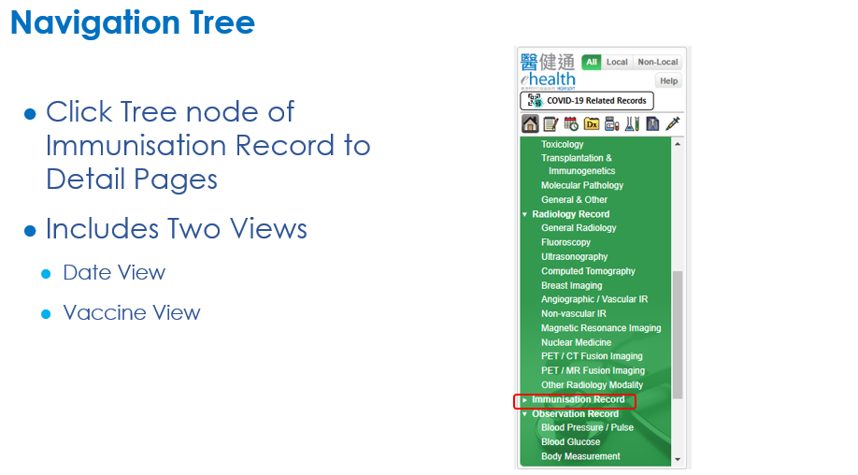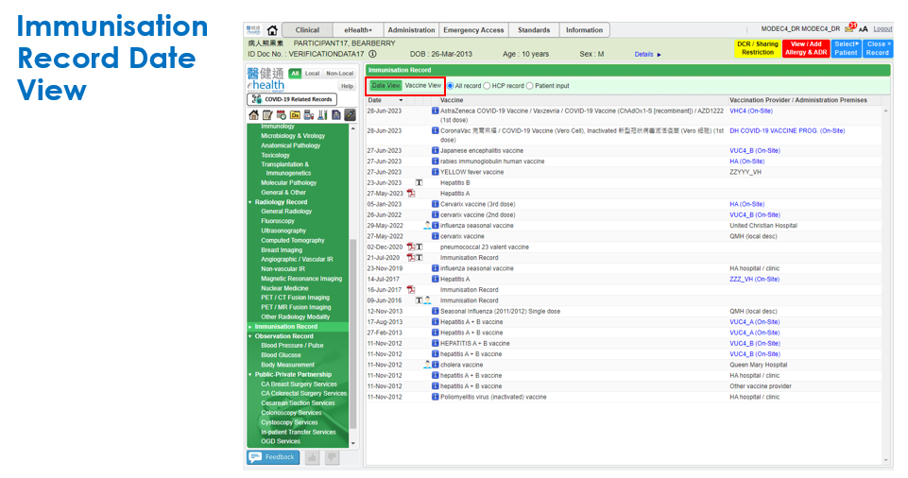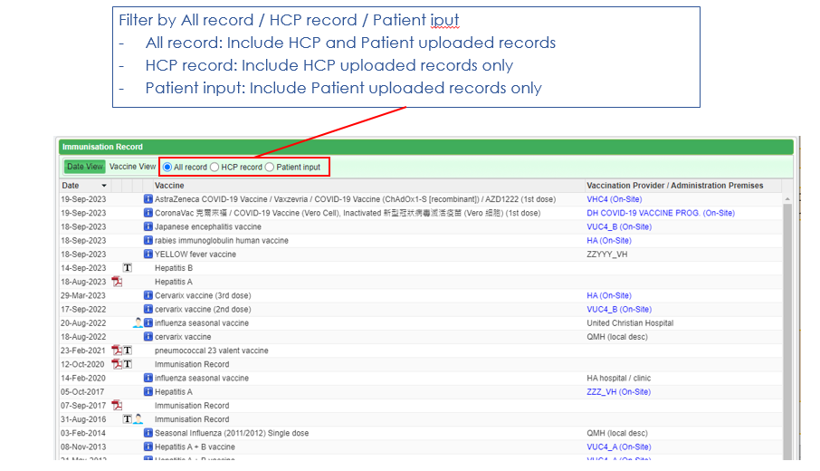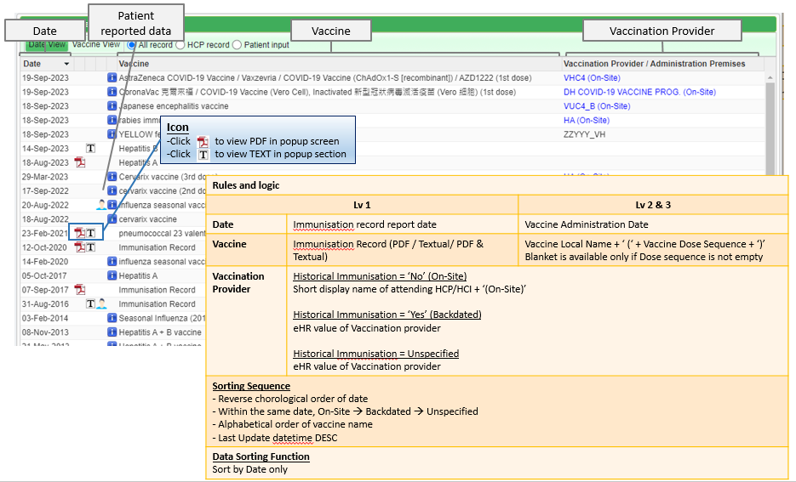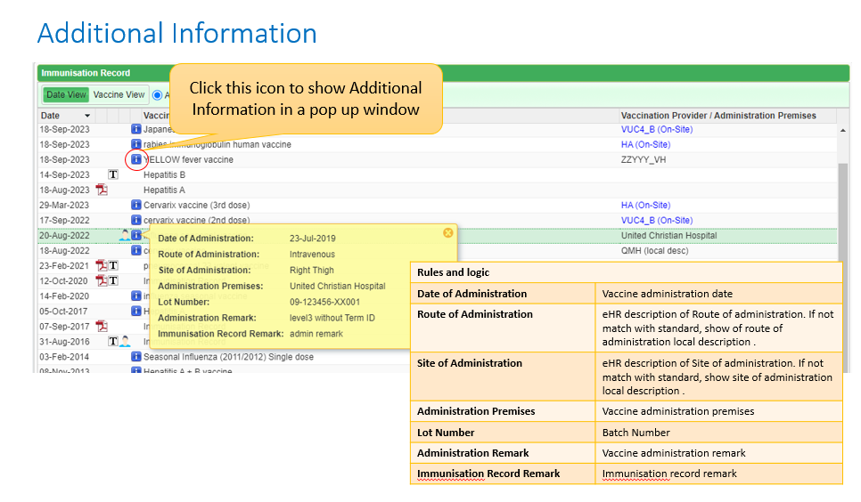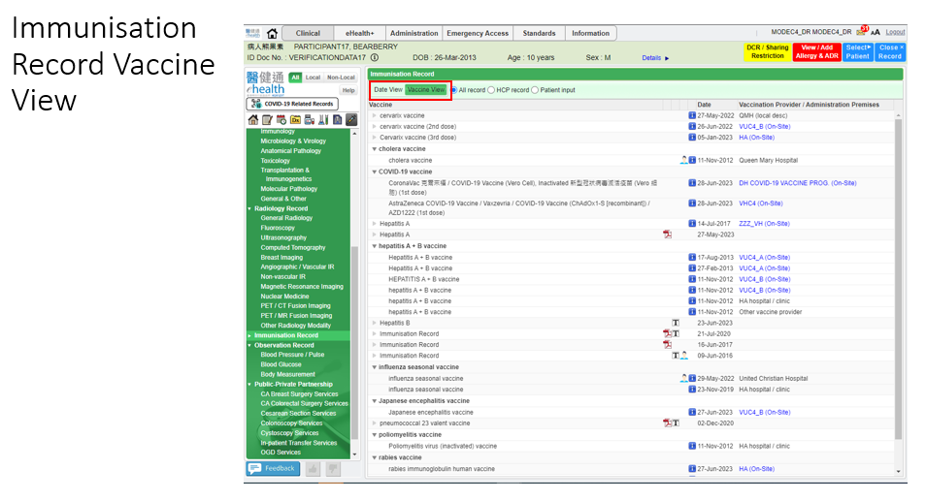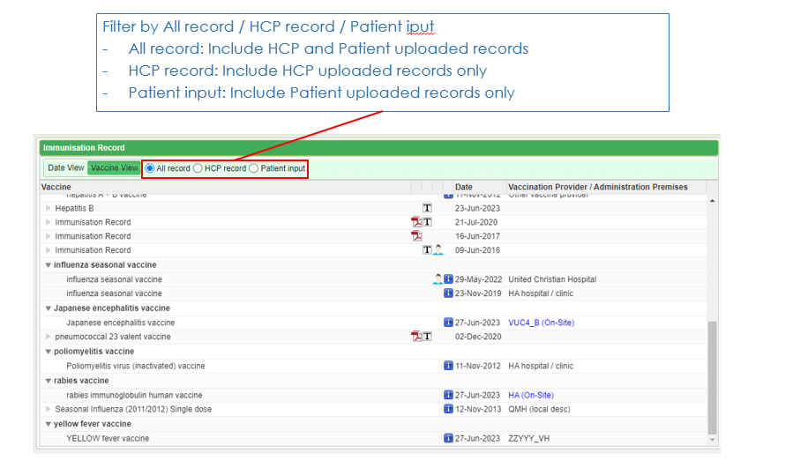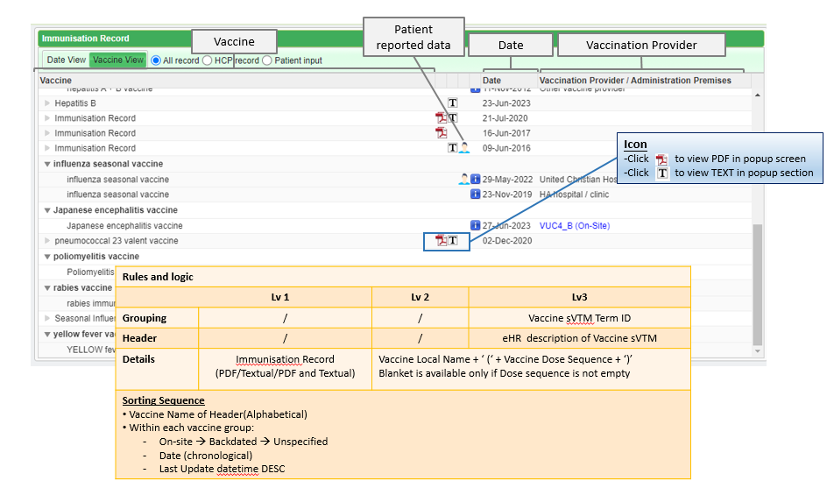

# Appendix – Actual Data Values (Sample)

If the actual values entered are various from the test case, please provide actual values as below.

If the value is not inputted, please use [BLANK] to indicate that empty value is inputted intentionally.

